Date ___________ Observer __________________ Site ________________

Plot Number ____ Canopy Species _______________ Canopy Cover________

Species | # | Rank/Cover | Browsed |  | Species | # | Rank/Cover | Browsed

Individual _____ #Leaves _____ Root–Apical length(cm)________ Notes__________
Individual _____ #Leaves _____ Root–Apical length(cm)________ Notes__________
Individual _____ #Leaves _____ Root–Apical length(cm)________ Notes__________
Individual _____ #Leaves _____ Root–Apical length(cm)________ Notes__________
Individual _____ #Leaves _____ Root–Apical length(cm)________ Notes__________
Individual _____ #Leaves _____ Root–Apical length(cm)________ Notes__________
Individual _____ #Leaves _____ Root–Apical length(cm)________ Notes__________
Individual _____ #Leaves _____ Root–Apical length(cm)________ Notes__________
Individual _____ #Leaves _____ Root–Apical length(cm)________ Notes__________
Individual _____ #Leaves _____ Root–Apical length(cm)________ Notes__________

< 30 cm height for woody; all plants counted; if > 20 then 1 (21-50); 2 (51-100); 3 (> 100); > 30 cm is a sapling; grasses/ferns use coverage class - 1 (1-10%); 2 (11-25%); 3 (26-75%); 4(> 75%); Browsed only if woody

Date ___________ Observer __________________ Site ________________

Plot Number ____ Canopy Species _______________ UTM N _________________

E _________________
Soil pH_______ % Moisture________ Canopy Cover________

Check N (native) or I (invasive) at each point vegetation touches the pvc pole
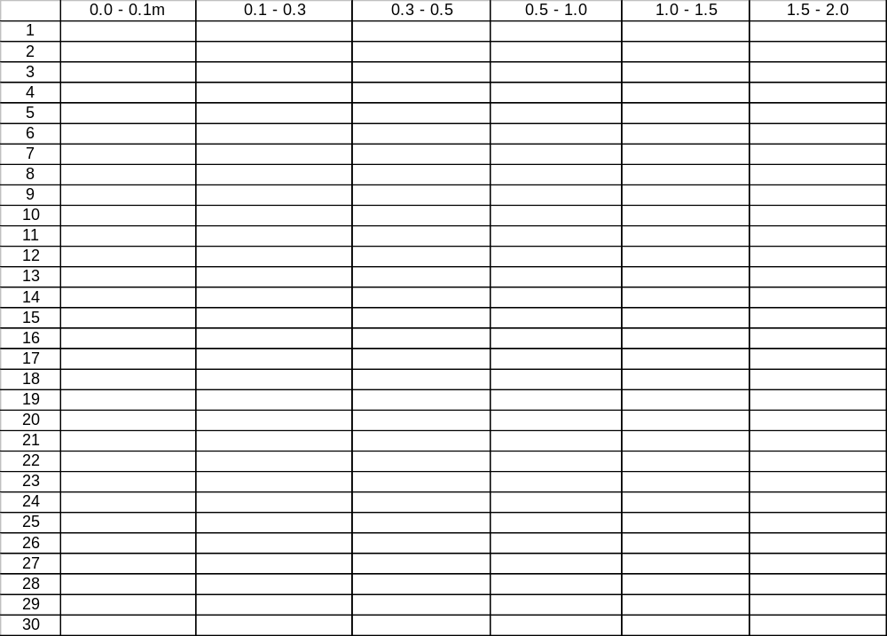

Saplings (>30 cm tall, within 3m square):

Species | # | Total twigs browsed | Total Twigs

